Connect Broadband establishes Videocon Advanced Communication Lab at PEC University of Technology on 19 November, 2015

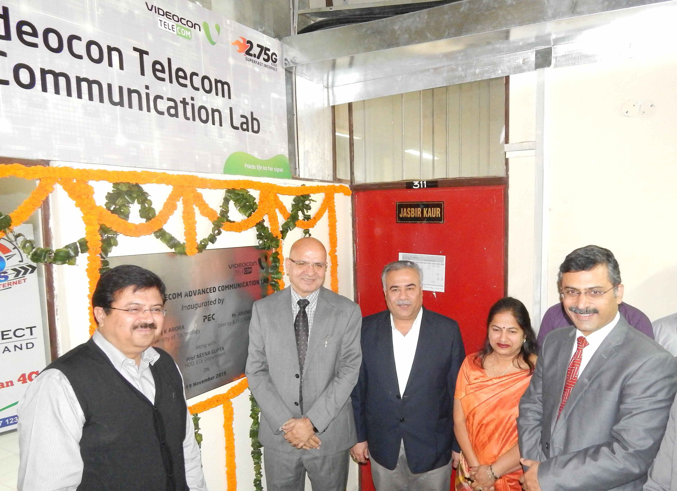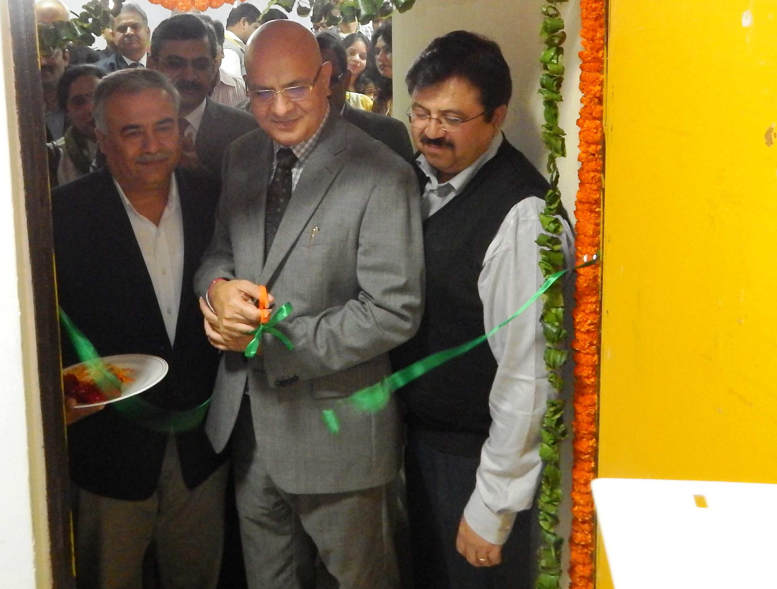

With an aim to enhance the standard of education in our country and in line with Government’s vision of DIGITAL INDIA, Videocon Connect, have taken a huge initiative to ensure that students get more practical education, making youth more employable. Connect Broadband has established and set up a Videocon Advanced Communication Lab at Department of Electronics & Communication of PEC University of Technology premises.

Mr. Arvind Bali, Director & CEO, Videocon Telecom and Connect Broadband, Mr. Manoj Arora, Director PEC University of Technology and Prof. Neena Gupta, Head, Electronics and Communication Department inaugurated the prestigious lab facility amid media, students and faculty members at PEC on 19 November, 2015. As technology leaders in the domain, Quadrant Televentures Limited has taken this major initiative for introduction of industry best practices with the budding engineers.

Videocon Advanced Communication Lab is equipped with latest technologies viz., FTTH (Fiber to the Home) with all network elements, GSM live BTS (Base Transceiver Station), CDMA live BTS (Base Transceiver Station) and WBB (Wireless Broadband). This would enable the PEC community to experiment on these technologies. Earlier this year in February, MoU was signed between Connect Broadband, operating under brand names of Connect Broadband and Videocon Telecom; and PEC University of Technology, Chandigarh for collaboration in sharing advancements in communication technology. As technology leaders in the domain;
1. A lab in the area of telecommunication namely VIDEOCON ADVANCED COMMUNICATION LAB has been established in the Electronics and Communication Engineering department of PEC University of Technology by Connect Broadband, equipped with latest technologies, for providing a live simulation environment and to impart practical technical knowledge to the students and faculty for Electronics and Communication Engineering (ECE) Department of PEC University of technology.
2. It shall help the Electronics and Communication Engineering (ECE) Department of PEC University of Technology, Chandigarh in developing the design facility (in AutoCAD) in the areas of wired and wireless system.
3. Setting up of the lab would benefit the faculty, Under Graduate (UG), Post Graduate (PG) and PhD students for lab experimentation, BE projects, ME / PhD Dissertation in the field of communication.
4. It shall help the industrial training, industrial tour and employment of the Under Graduate, Post Graduate students of ECE department.
5. It shall help in improving the technical skills of the faculty by providing up to date technology development training from time to time.
6. It shall provide hands on experience of live technologies and hence better technical understanding of the same.
7. It shall create the opportunity for PEC students to work on projects like, RF optimization, Network planning, EMF, Transmission, Broadband (Wi-Fi and DSL) etc.
8. It shall also impart the students to use the lab for exploring new and fresh innovative ideas and support for the same will be provided by Connect Broadband.
9. It shall also provide the knowledge regarding WBB (Wireless Broadband), FTTH (Fiber To The Home), GSM live BTS (Base Transceiver Station) and CDMA
This arrangement is on Non-commercial basis.

Speaking on the inauguration ceremony, Mr Arvind Bali, Director and CEO of Videocon Telecom and Connect Broadband said, “We strongly believe that industry and academia have to work closely to establish centres of excellence. In international markets this has been the trend and we want to lead this culture in India as well. These engineering students are going to be the drivers of technology in future. We strongly believe that it is our responsibility to expose them to the technological developments around the globe. We have taken this initiative to ensure closer coordination with one of the most prestigious technology institutes in the region.”

“This is the second such lab set up by QTL (Connect Broadband & Videocon Telecom). Earlier the company has already established an advanced technology lab in Chitkara University. Plans for setting up two more labs are in the pipeline i.e. Thapar University and Rayat and Bahara University. In the next 12 months Connect and Videocon propose to establish 10 more such labs in all the leading engineering institutes. An investment of Rs 5 Cr has been earmarked for the same”, added Mr. Bali.

Mr Manoj Arora, Director PEC University of Technology said, “We appreciate Videocon Connect for this initiative. It will help our students keep pace with the technological advancements in Communication Engineering. I am sure the students and the faculty will gain immensely from the interaction with the business group”.

